Multiscale Modeling - 2 report

# Introduction

During second part of classes previous version of program has been extended by some additional types of simulations. One of the key features is reproduction of recrystallization process that is determined by energy distribution of each cell and uses modified Monte Carlo method. Second feature is mentioned before Monte Carlo algorithm that can be used for simulating metal microstructure. Last feature is implementation of two step automatons on which recrystallization is based. It was initially used for simulating dual phase structures.

# UI changes – Description

Picture number one shows how main window look like after changes that was done. On this picture we can see all available options and settings and also visualized result of simulation.

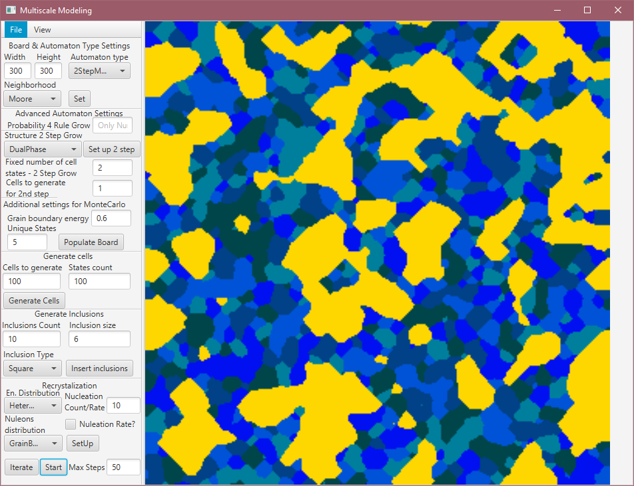

Picture 1 Main window of application

On the left hand was added:

* View menu that contains options “Show Energy” that shows window with distribution of energy (For recrystallization only) – picture 2. On this energy distribution grid each cell is painted with color corresponding to its energy level (more cell energy – lighter color).

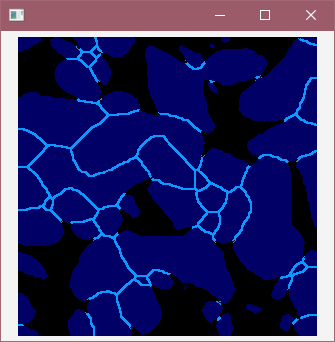

Picture 2 Window with energy distribution

* In section “Board & Automaton Type Setting” now we can specify some additional automaton types:
  + 2StepNGG-NGG (First & Second step is Naïve grain grow)
  + 2StepNGG-MC (First step is Naïve grain grow, second Monte Carlo)
  + 2StepMC-NGG (First step is Monte Carlo, second is Naïve grain grow)
  + 2StepMC-MC (First & Second step is Monte Carlo)
  + RecrystallizationMC (Initial simulation is Monte Carlo)
  + RecrystallizationNGG (Initial simulation is Naïve grain grow)

As previously when we have provided setting we need to initialize simulation using “Set” button

* Section “Structure 2 Step Grow” was modified, now contains:
  + Type of simulation of two step:
    - Substructure (Specified amount of unique cells will remain and rest of board will be populated with new cells for second step of simulation)
    - Dual Phase (Specified amount of unique cells will be changed to GOLD colored cells and rest of board will be populated for second step)
  + Amount of unique cells that should be present in second step
  + Amount of cells that should be generated prior of running second step
* There was added section “Additional settings for Monte Carlo” that contains:
  + Field which specifies number of unique cells that should be dispersed on the board
  + Energy of grain boundary (should be in range from 0.1 to 1.0)
* Last section that was added is “Recrystallization”. It contains:
  + Type of energy distribution
    - Homogenous (for all cells will be set energy value of 2.0)
    - Heterogenous (cells on grain boundaries will receive energy value of 7.0 and the rest of them 2.0)
  + Nucleations count – specifies how much nucleation should be places on the board prior running recrystallization phase
  + Nucleations distribution – where nucleations should be placed
    - Random
    - Grain Boundaries

# Examples of implemented functionalities

## 2 Step automaton – substructure

Picture 3 (prior running second step) and 4 (result of finished simulation) shows two step automaton which start with Naïve grain grow and on second step Monte Carlo algorithm is used. Simulation was executed with settings that are specified below this pictures.

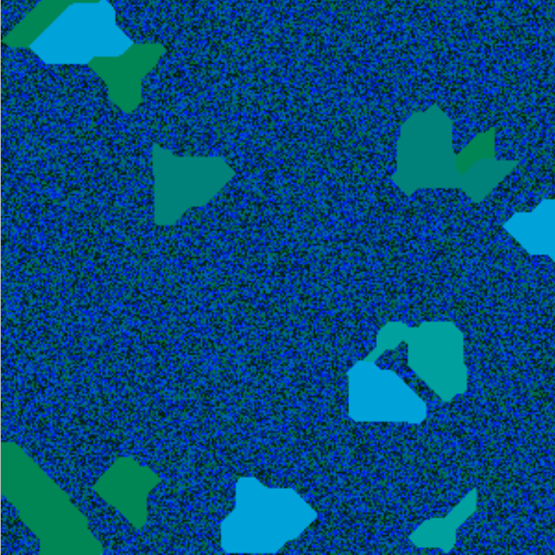

Picture 3 Example of two step automaton prior running second step (chosen unique cells and populated board)

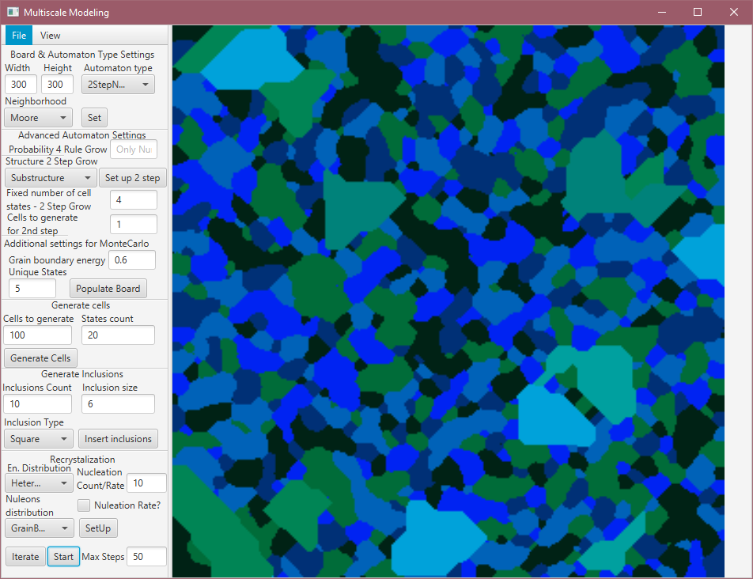

Picture 4 Result of second step in two step automaton

Parameters of simulation:

* Dimensions of grid: 300x300 cells
* Moore neighborhood
* 20 unique cells that was randomly spread with count of 100
* Substructure type: Substructure
* Number of fixed cells: 4
* Unique states (count of unique cells to disperse on board for Monte Carlo): 5
* Grain boundary energy: 0.6

## 2 Step automaton – dual phase

Picture 5 (prior running second step) and 6 (result of finished simulation) shows two step automaton which start with Monte Carlo and on second step Naïve grain grow is used. Simulation was executed with settings that are specified below this pictures.

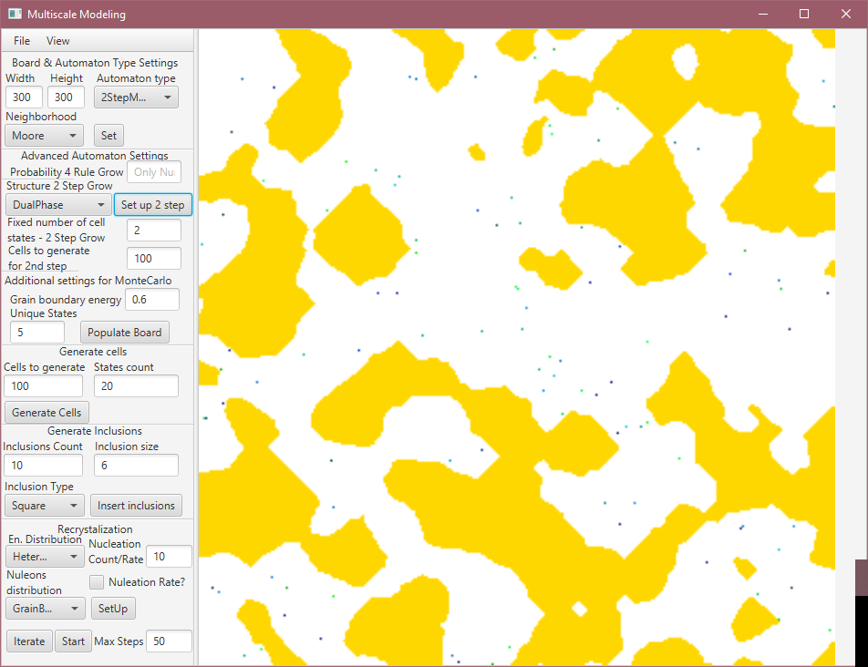

Picture 5 Example of two step automaton prior running second step (chosen unique cells and populated board)

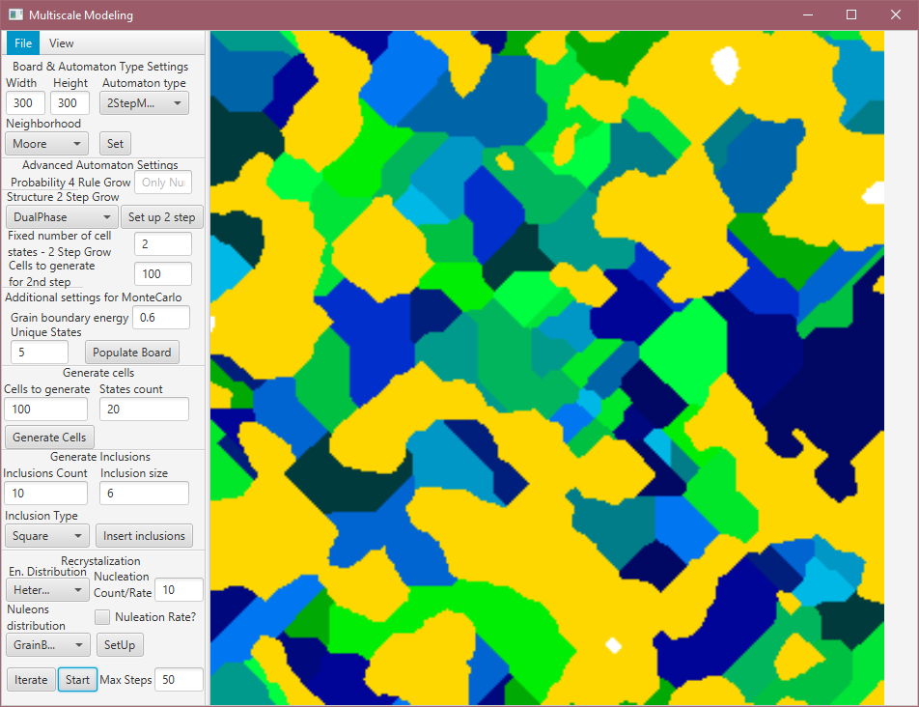

Picture 6 Result of second step in two step automaton

Parameters of simulation:

* Dimensions of grid: 300x300 cells
* Moore neighborhood
* 20 unique cells that was randomly spread with count of 100
* Substructure type: Dual Phase
* Number of fixed cells: 2
* Cells to generate (for Naïve grain grow): 100
* Unique states: 20
* Unique states (for first step MC): 5
* Grain boundary energy (for first step MC): 0.6

## Recrystallization

This is example of recrystallization that is started from Naïve grain grow. Picture number 7 and 8 shows result of finished naïve grain grow and set upping recrystallization stage. Picture 9 and 10 shows result of simulating recrystallization after 50 iteration over the board. Settings that were used are specified below this picture.

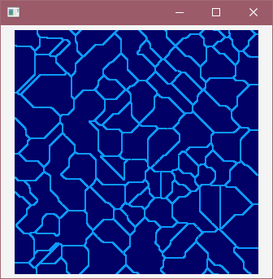

Picture 7 Energy of cells prior running recrystallization

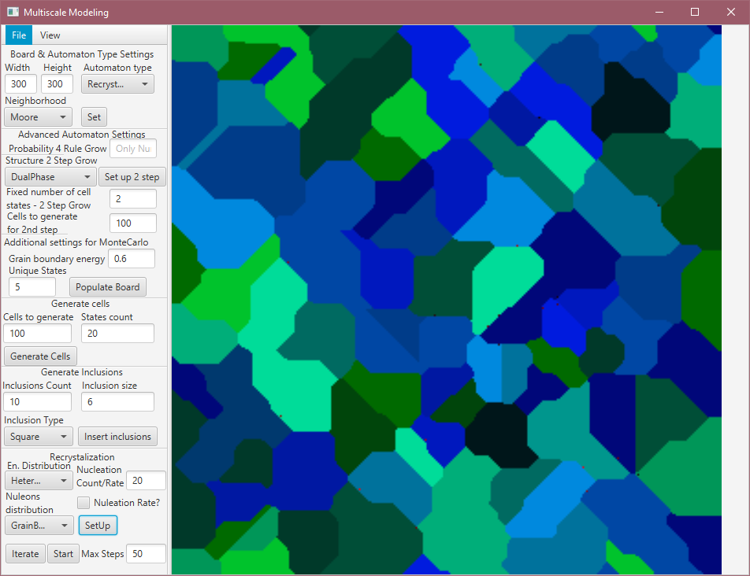

Picture 8 Grains obtained from naïve grain grow prior running recrystallization

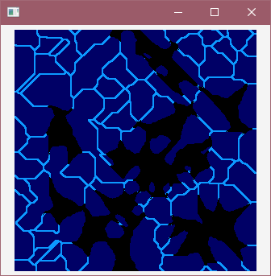

Picture 9 Energy of cells after running recrystallization

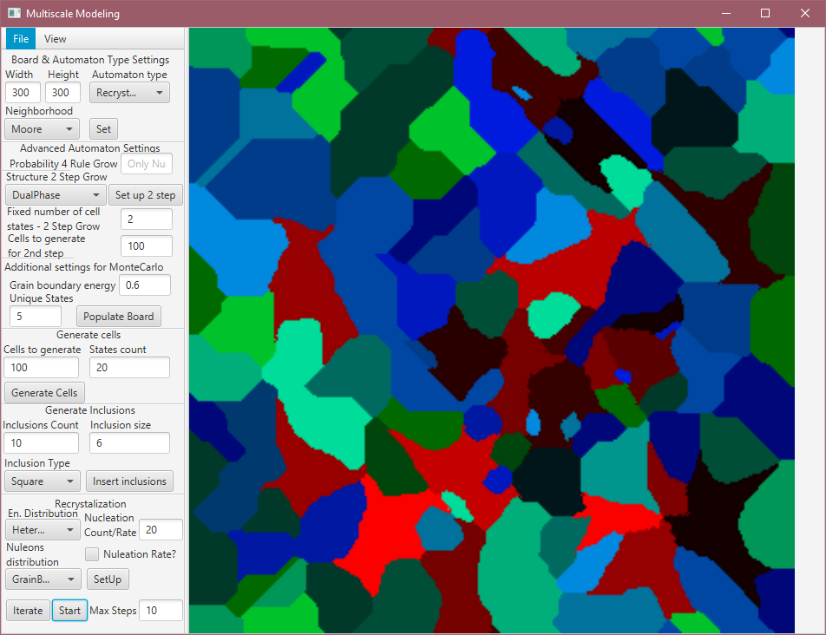

Picture 10 Result of running recrystallization

Parameters of simulation:

* Dimensions of grid: 300x300 cells
* Moore neighborhood
* 20 unique cells that was randomly spread with count of 100
* Energy distribution: Heterogenous
* Nucleons distribution: Grain Boundaries
* Nucleation count: 20
* Steps of simulation: 50

# Comparison between simulation and actual metal structure

### Recrystallized carbon steel

First example is carbon steel metal alloy that was intercritically annealed at 775 °C. (Picture 11). In comparison picture 12 is representing implementation of recrystallization set up with parameters:

* Dimensions of grid: 300x300 cells
* Moore neighborhood
* 20 unique cells that was randomly spread with count of 100 (for first step that was Naïve grain grow)
* Energy distribution: Homogenous
* Nucleons distribution: Grain Boundaries
* Nucleation count: 100

There is a lot of similarity in those two pictures. In implementation we can find differently sized and shaped grains that are in the structure of real metal.

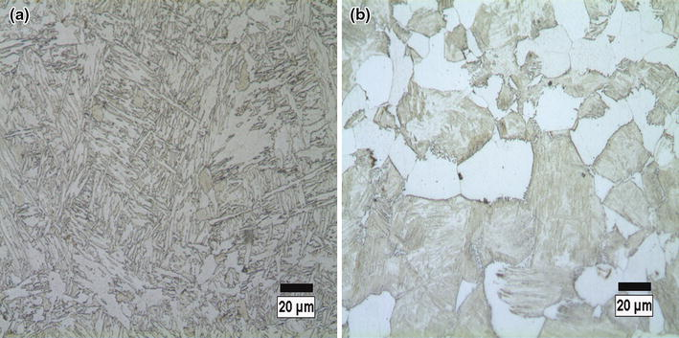

Picture 11 Recrystallized carbon steel alloy (source: http://www.amse.org.cn/article/2014/1006-7191-27-2-279/40195_2014_43_Fig3_HTML.jpg.html)

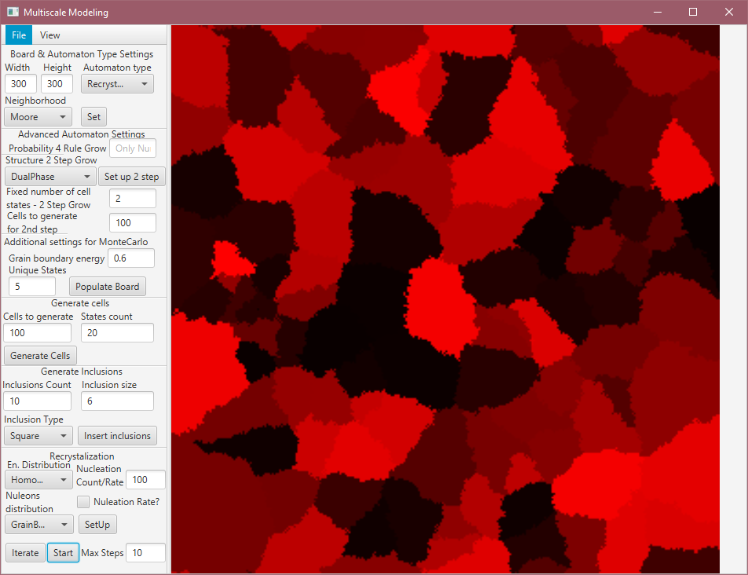

Picture 12 Result of recrystallization simulation

### Steel that was slowly cooled

Second example is standard steel microstructure that was slowly cooled (Picture 13). In comparison, picture 14 is representing progress of implemented recrystallization simulation. Picture 15 shows one moment in distribution of energy. The most important thing in this simulation is recrystallization along borders of grains. Parameters that was set:

* Dimensions of grid: 300x300 cells
* Moore neighborhood
* 20 unique cells that was randomly spread with count of 200 100 (for first step that was Naïve grain grow)
* Energy distribution: Heterogenous
* Nucleons distribution: Grain Boundaries
* Nucleation count: 100
* Steps of simulation: 40

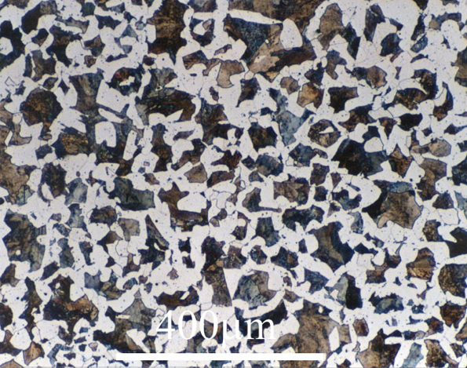

Picture 13 Allotriomorphic ferrite in a Fe-0.4C steel which is slowly cooled (source: https://www.phase-trans.msm.cam.ac.uk/2008/Steel_Microstructure/SM.html)

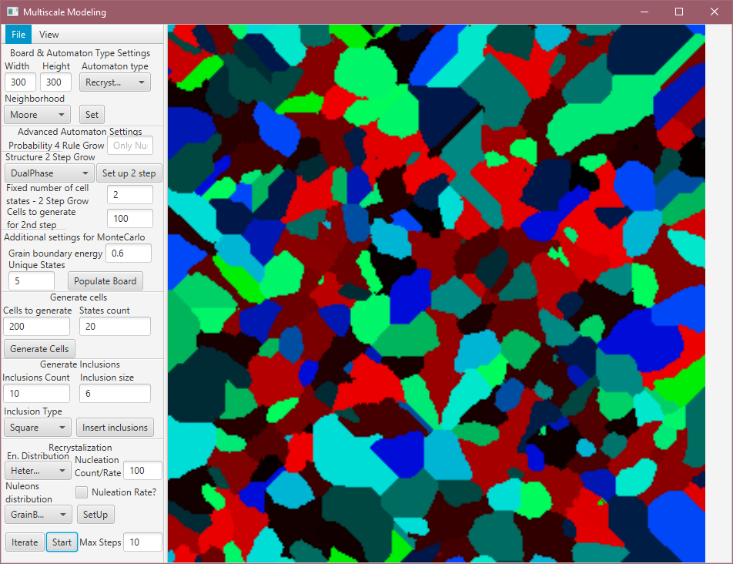

Picture 14 Result of four recrystallization simulation

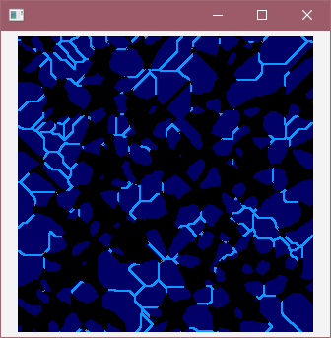

Picture 15 Energy distribution in recrystallization simulation

Compering those pictures from simulation and real structure we can see similarities in the process of recrystallization which is replacing old grains with new ones.

# Conclusions

While using Monte Carlo algorithms was possible to simulate process of metal structure recrystallization. The result of simulation quite good resembles actual metal alloy structure which proves correctness of implementation. One of the biggest drawbacks of this method for recrystallization comes from Monte Carlo algorithm that is based on random selection of cells which cause significant decrease in performance.

All cellular automata are very flexible for various of simulations. Unfortunately there is major restriction in size of simulation that this program can generate. The biggest problem here is memory usage and spreading tasks between multiple cores in processor.